Micro Goal
Ideation Phase
Define the Problem Statements
Date | 16 Feb 2026
Team ID | SWTID-2026-7531
Project Name | MicroGoal
Maximum Marks | 2 Marks

[Text Wrapping Break]
Problem Statement
In many cities, garbage bins overflow because waste collection is not done at the right time. This causes bad smell, diseases, and environmental pollution.
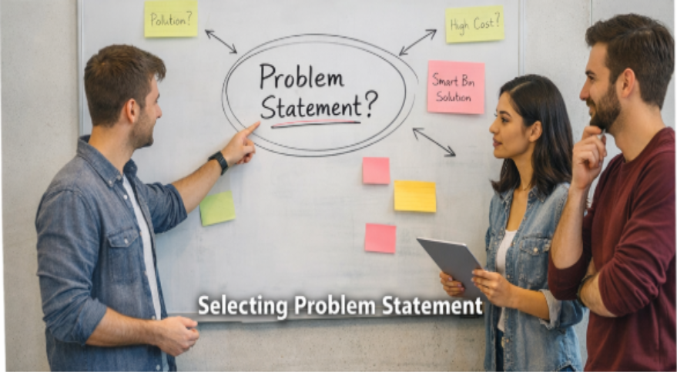

ID | I am | I'm trying to | But | Because | Which makes me feel
1 | A student | Manage my daily goals online | There is no simple secure system | Most apps are complex or unsafe | Frustrated
3 | A beginner developer | Build a goal management backend | Hard in implementation | JWT and middleware setup is complex | Confused
4 | A user | Access my goals anytime | Some softweres are not structured properly | Poor backend arch | Not satisfed

